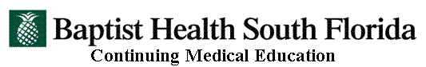

Echocardiography Symposium – 36th Annual
Friday-Saturday, October 27-28, 2017
Hilton Airport Hotel, Miami, Florida

Please register by Friday, October 20.

Symposium Registration

Name (Please Print Clearly!)

Degree: □ M.D. □ D.O. □ Ph.D. □ P.A. □ ARNP □ R.N. □ Sonographer □ Respiratory Other_________________

_________________________________________________________________________________________________
Institution Affiliation

_________________________________________________________________________________________________
Mailing Address City/State/Zip

_________________________________________________________________________________________________
Telephone Fax Email Address

_________________________________________________________________________________________________
License Number (Required for Florida healthcare professionals)

Symposium Fees:* Please check all that apply.

Physicians** – $425 Other Healthcare Professionals – $225
Baptist Health Employees – $60 Physicians in Training*** – $225

Check enclosed (Payable to Baptist Health CME Department)

Credit Card Type:
PAYMENT INFORMATION
Name on Credit Card:
Credit Card Billing Address:
City, State and Zip code:
Credit Card #: | Expiration Date (mm/yy):
Authorized Amount $ | Security code:

Authorized Signature___________________________________________________________

